Software Requirements Specification
for
Tenant Management System

Version 1.0

Prepared by:
Muhammad Fateh Tariq
Muhammad Osama Syed
Zia Haider

Apex Software

Date Created: 14/06/2019

Table of Contents

Table of Contents ii
Revision History iii
Introduction 1
Purpose 1
Document Conventions 1
Intended Audience and Reading Suggestions 1
Product Scope 1
References 1
Overall Description 2
Product Perspective 2
Product Functions 2
User Classes and Characteristics 2
Operating Environment 3
Design and Implementation Constraints 4
User Documentation 4
Assumptions and Dependencies 4
External Interface Requirements 5
User Interface Mock-ups 5
System Features 6
Context Diagram 6
Use case Model 6
Use case Narratives 6
Activity Diagram (for each use case) 6
Activity Diagram (Complete System) 6
Other Nonfunctional Requirements 6
Performance Requirements 6
Safety Requirements 6
Security Requirements 6
Software Quality Attributes 6
Appendix A: Glossary 7
Appendix C: To Be Determined List 8

Revision History

Name | Date | Reason for Changes | Version

Introduction

Purpose
The Product that is specified in this Document is the Tenant Management System which is to be made for Umer Associates. The overall goals of the system are to keep track of tenant maintenance requests, tenant record, document and contract management, to make it easier to the tenants and controlling the rental payment.

Document Conventions
Font: Calibri
Size: 11
Important Text and numerous Terminologies throughout the Document have been Bold for easier Identification.

Intended Audience and Reading Suggestions
The intended Audience for the Following Document is as follow:
- Project Manager
- Developers
- Simulation Engineer
- Tester

Product Scope
The main aim of the Software is to allow Effective Communication between the Tenants and the concerned personal of the Apartment Rental Organization and to make day to day tasks for the Organization and Tenants easier and more effective. The Software will help in Automation of the Organizations current system which will indefinitely help in solving the common problems the Organization and the Tenants faced every day.

References
None

Overall Description

Product Perspective
The Software will be a complete Over hall of the current system the Organization Uses. The Software aims to bring major Automation to key aspects of the System and will be constructed from scratch, but the core foundation of the current System will be kept in mind.

Product Functions
- Request a change of apartment.
- Request a maintenance petition.
- Complaints.
- Pay the rent on-line through application.
- Add a new tenant and make and managing his/her contract.
- Warn and report any tenant about his/her rental payment.
- Report any interesting information (new services, taxes, etc)
- Manage the tenant maintenance request, and reporting about it.
- Report about any tenant maintenance tasks.
- Report about any periodical building maintenance.
- Pick up the manager request to the central administration.
- Report about the tenant rent payments.
- Report about the maintenance services.
- Request available services.
- Report and send tenant contract or documents.

User Classes and Characteristics
The Software will be Operated by the following:
- Landlord: The Landlord has the highest authority and command over the Staff and Managers and has the highest security clearance.
- Managers: The Managers come second in command to the Landlord and perform tasks which are second in precedence and Reports to the Landlord.
- Security Manager: Responsible for managing tasks related to Security and Report to Managers.
- Staff: The Staff comes after the Managers and are also responsible for performing various key tasks.
- Tenants: The people residing at the Apartment Complex that don’t perform any roles in managing the Apartment Complex aside from paying Rent.
- Prospect Tenants: Potential Tenants that are looking for Apartments.

Operating Environment

Hardware Requirements
Processor: Intel Core Duo 2.0 GHz or more
RAM: 1 GB or More
Hard disk: 80GB or more
Monitor: 15” CRT, or LCD monitor
Keyboard: Compatible Keyboard
Mouse: Compatible mouse

Software Requirement
Front End:
Visual Basic 2005 Express Edition
With SQL Server Compact Edition
Microsoft SDK 2.0
Or
Visual Basic 2008 Express edition
With SQL Server Compact Edition
Microsoft SDK 3.0
Back End:
MS SQL Server
Operation System:
Windows Vista / 7 / 8 /10 (x86 / x64)

Mobile Application Requirement
Android (Version 5.0 and Above)
An Internet connection is also essential.

Design and Implementation Constraints
Developer Team is Short Handed which could result in additional time being taken. Implementation of the Payment through Credit Card System in which 3rd Party Organizations may need to be involved. A Database Manager may be needed from a 3rd Party Organization.

User Documentation
A Comprehensive User Manual with various Online References and a Hotline for any technical Queries.

Assumptions and Dependencies

Assumptions

- All payments are processed online through the payment system
- Payment System accepts all major credit cards and debit cards.
- Payment system is informed of credit reports, to determine if a tenant is a potential credit risk.
- The managers may report to the system with information about credit reports, risks and rental occupation.
- Rent is due on the 1st of the month.
- Before leases can be accepted or renewed, the landlord must manually view a credit report.
- Probable causes for lease termination, induced by the landlord, include: non-payment of rent after 60 days, tenant requests termination, extensive destruction to the property by the tenant, illegal activity going on inside an apartment, housing of pets strictly forbidden by the lease. Other extenuating circumstances are handled on a case-by-case basis with involvement of the tenant, landlord and possibly the courts.
- In the event of a non-consensual lease termination, the legal burden will be on the landlord to begin the eviction process through the Area’s Police Station. The landlord will flag the lease as an eviction in the TMS.
- Old Tenant information is kept in the system archived for a period of 7 years, then purged from the database.
- Apartment changes must be submitted into TMS with an extensive written description of why a tenant or landlord is requesting the change. Changes must be approved by both parties in the TMS.

Dependencies
- Database Manager used by a 3rd Party Company.
- Apartment Inspection and Report generated by a 3rd Party Body.

External Interface Requirements

User Interface Mock-ups
The Desktop Application will consist of a default Windows 10 Styled Minimalistic Design with SogoeUI Font.
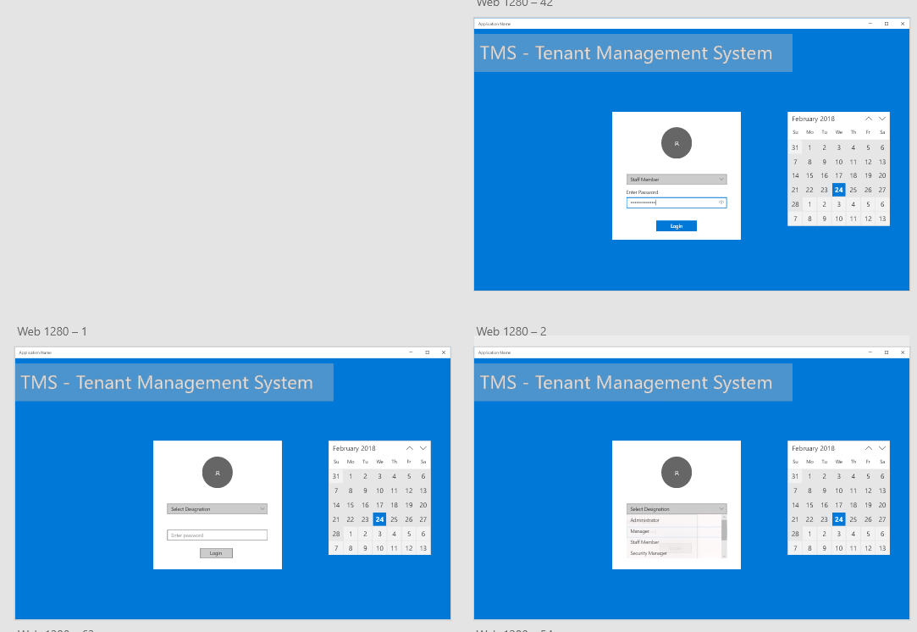
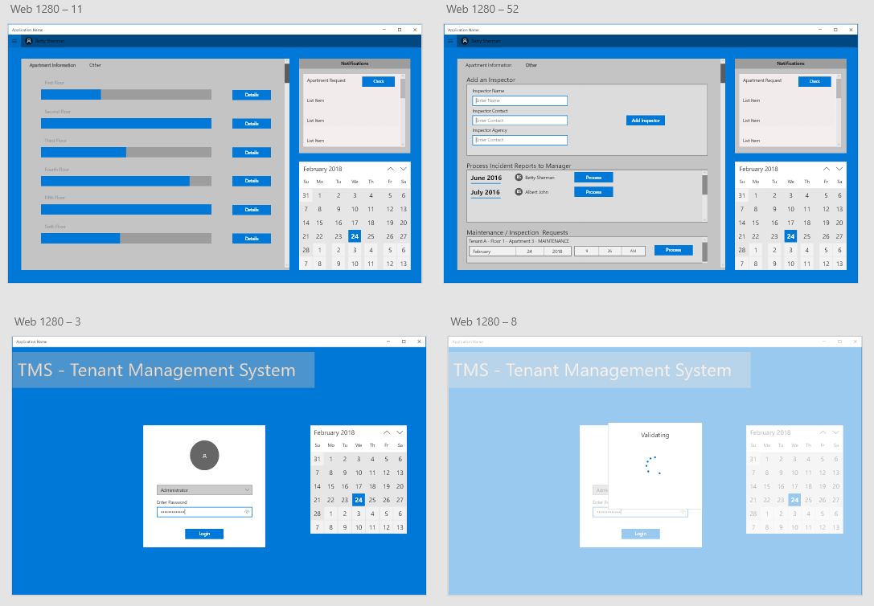
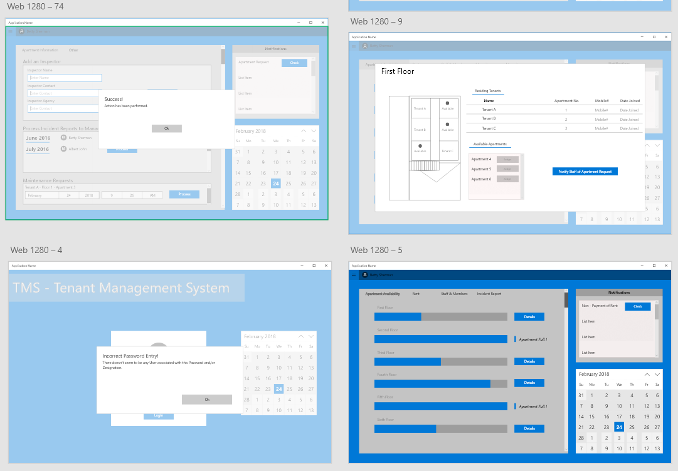

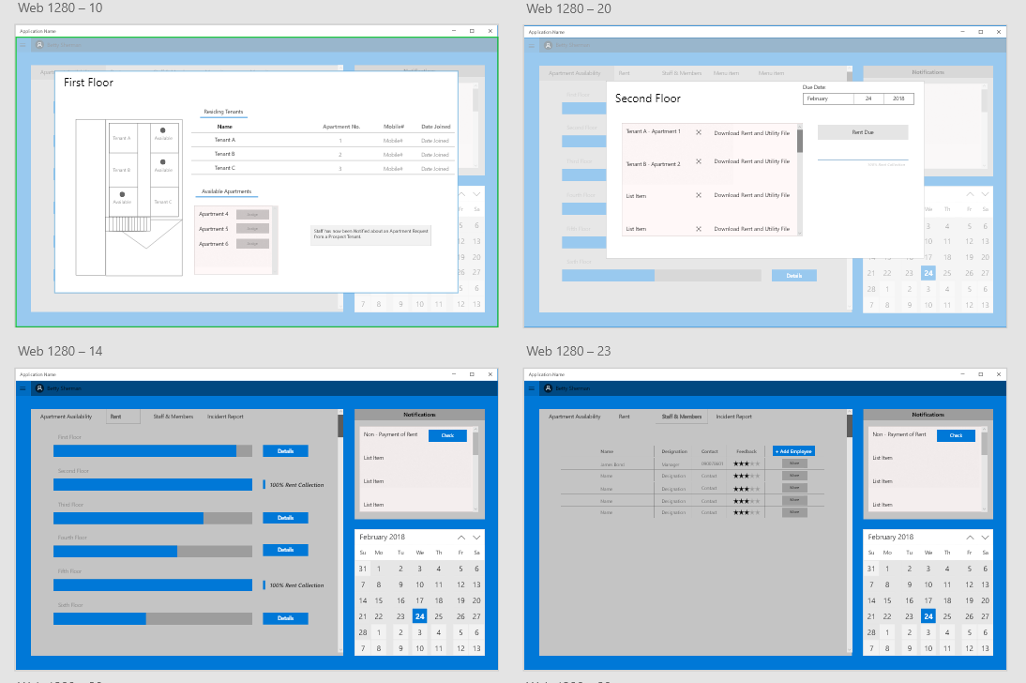
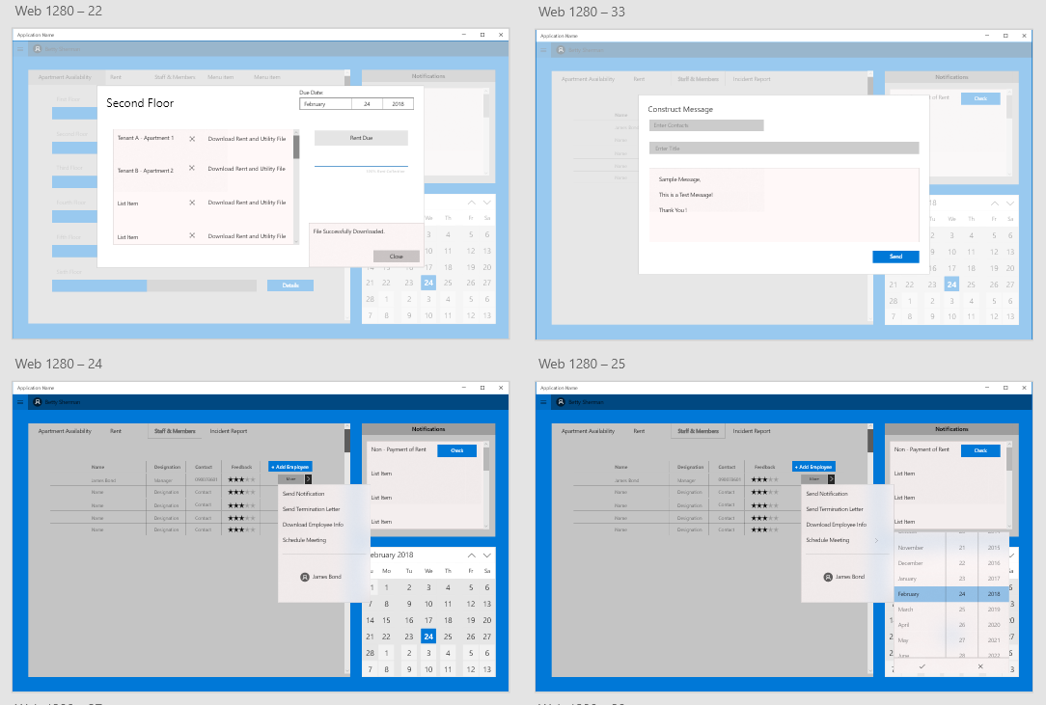

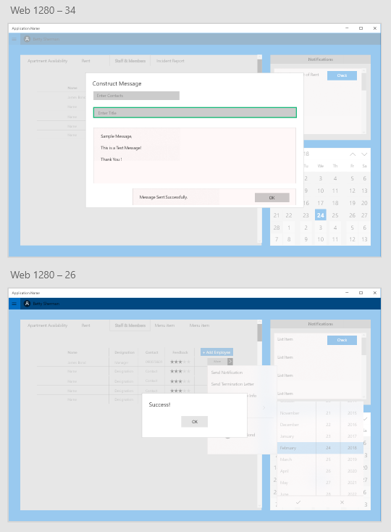
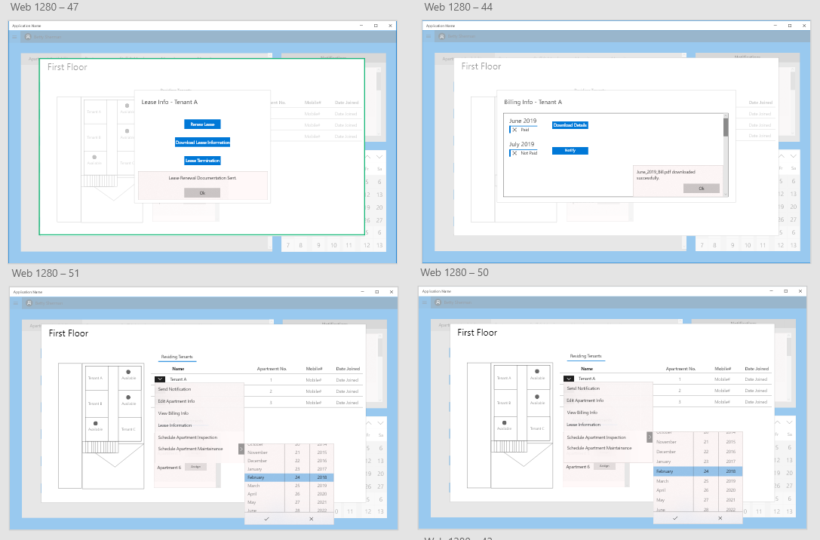
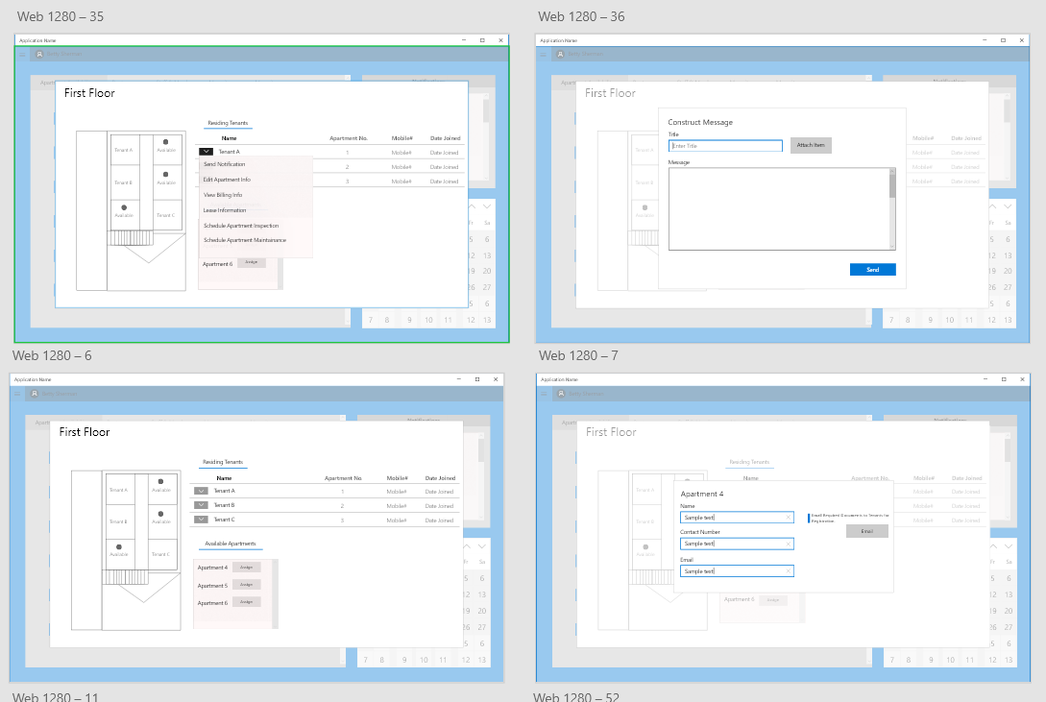
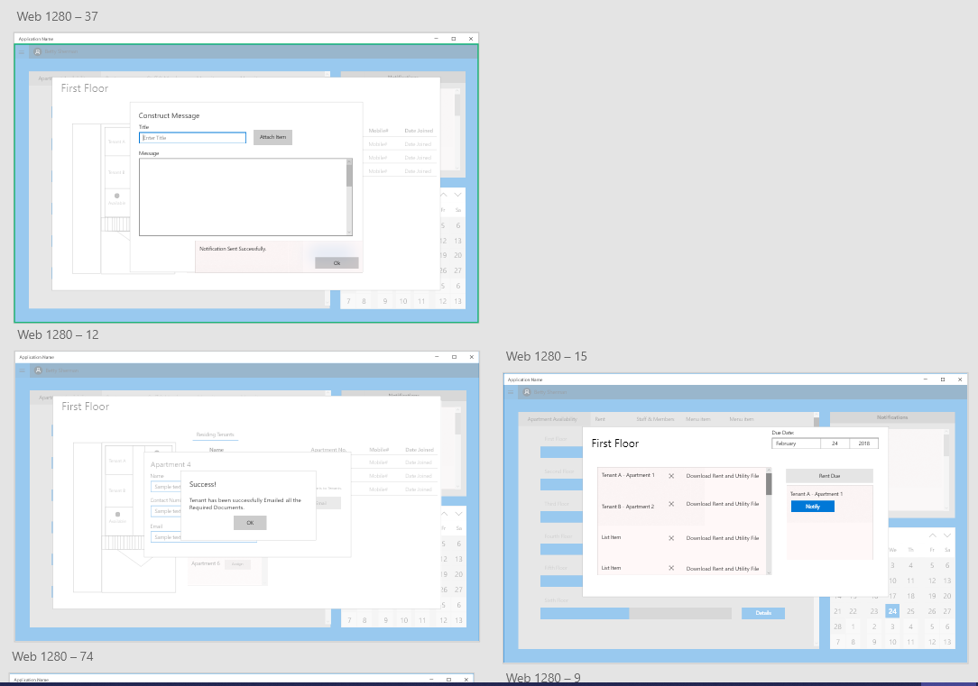
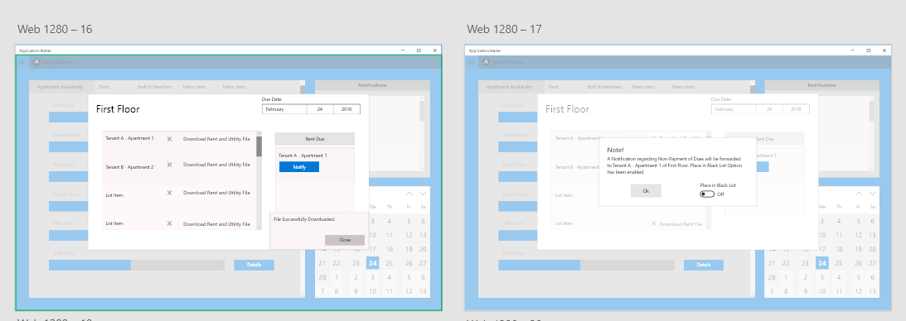
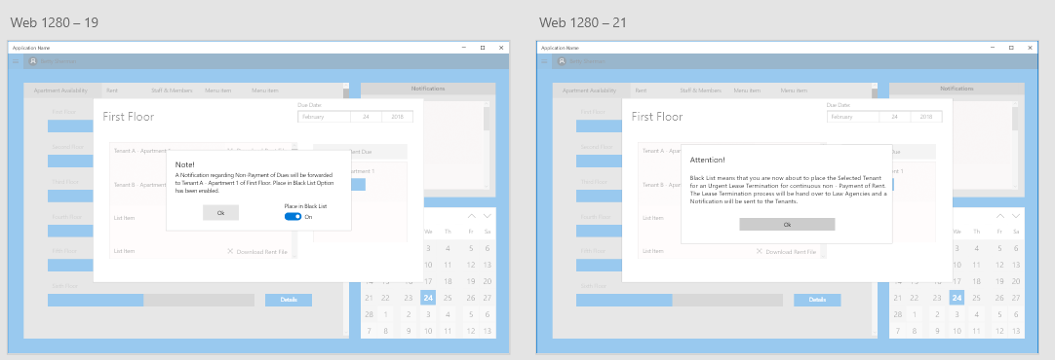
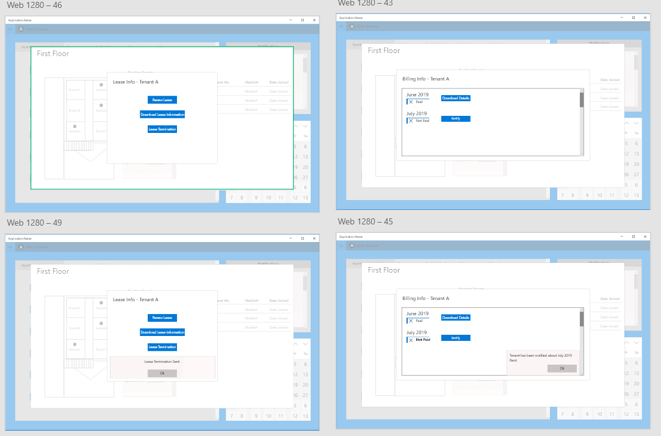
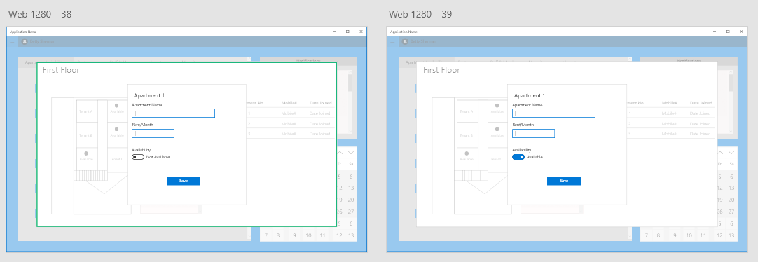
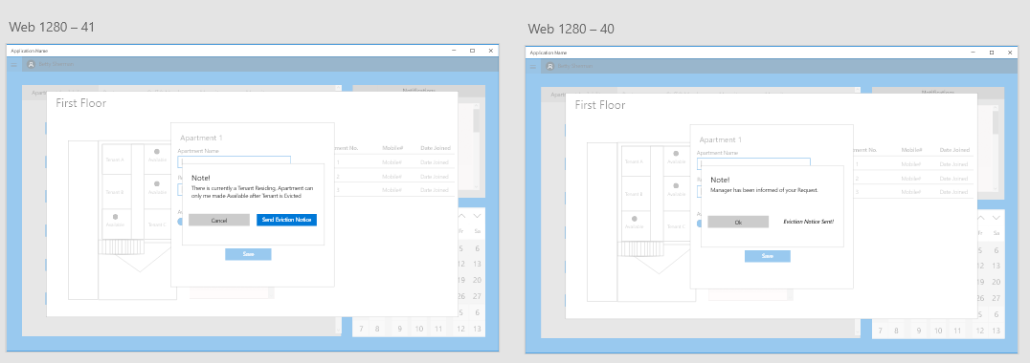
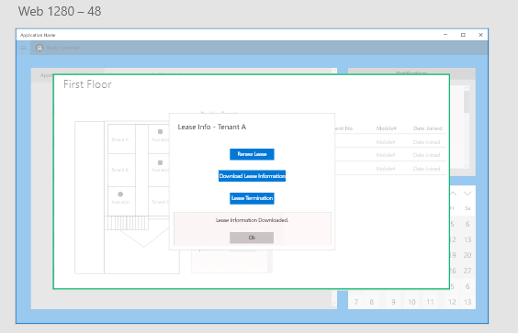
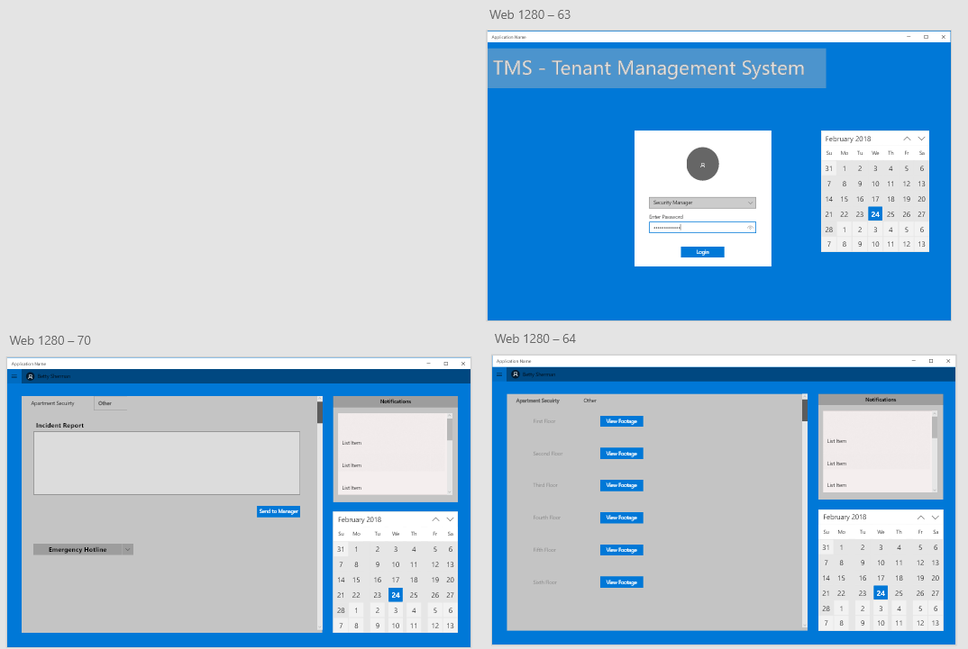
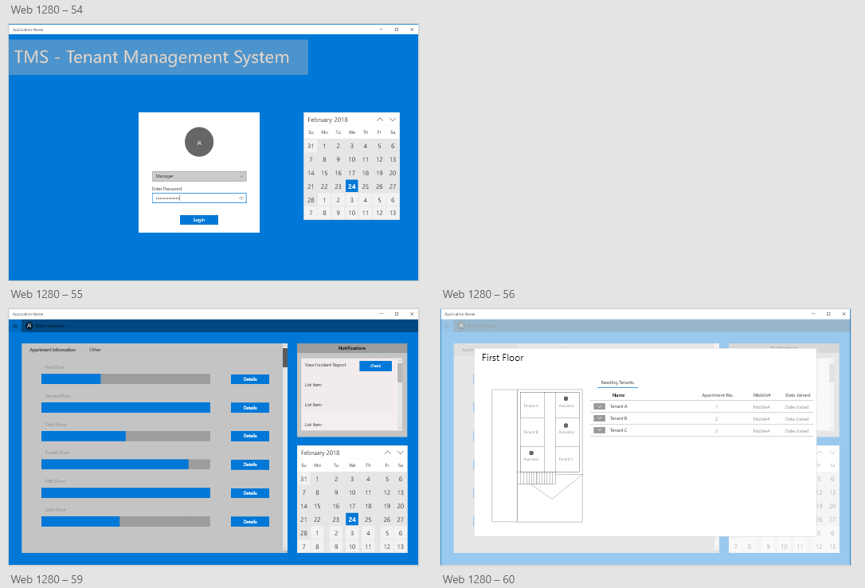
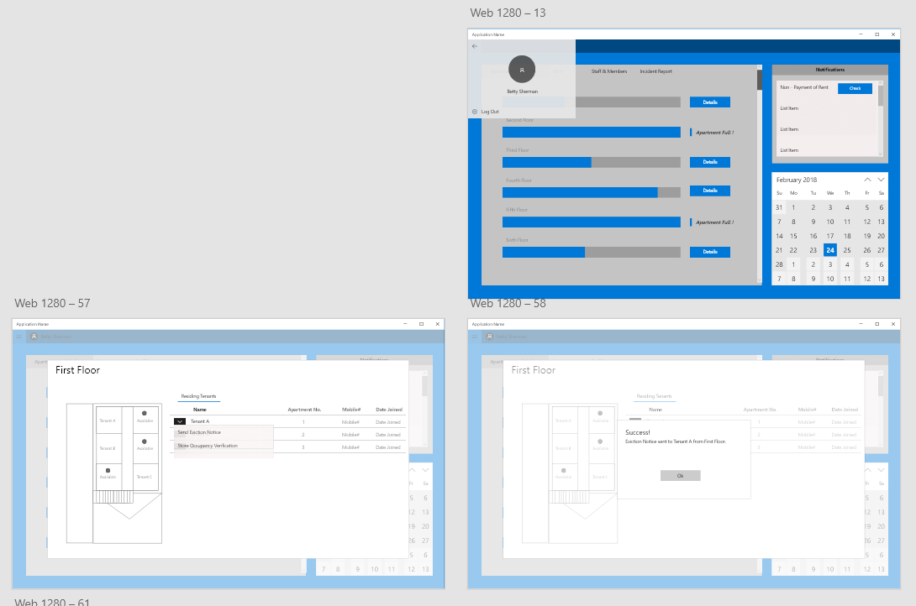
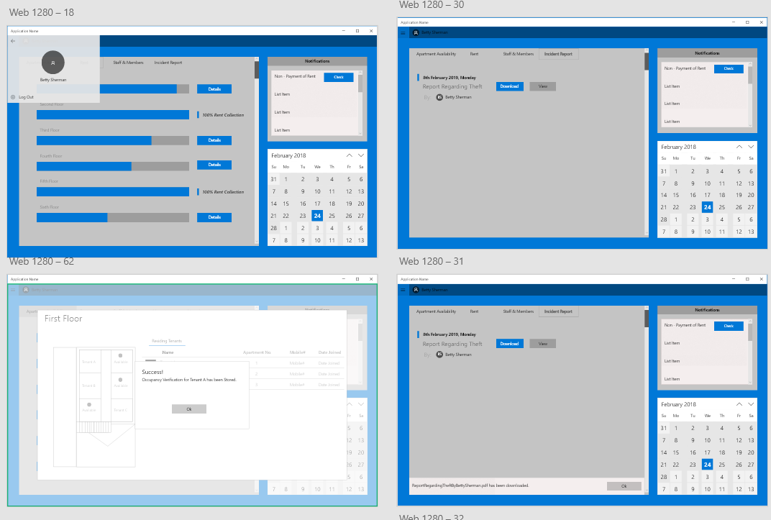
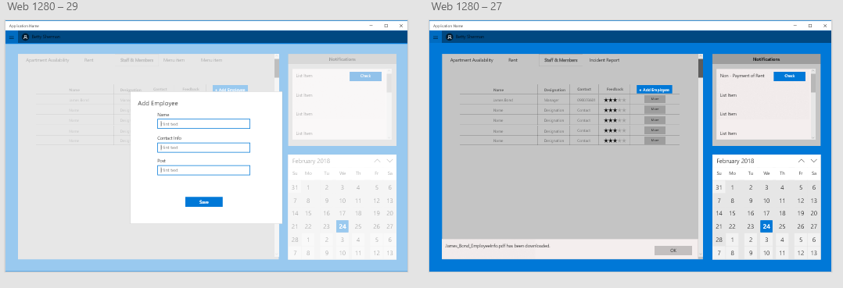
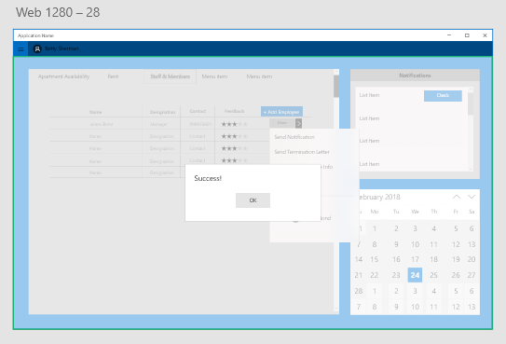
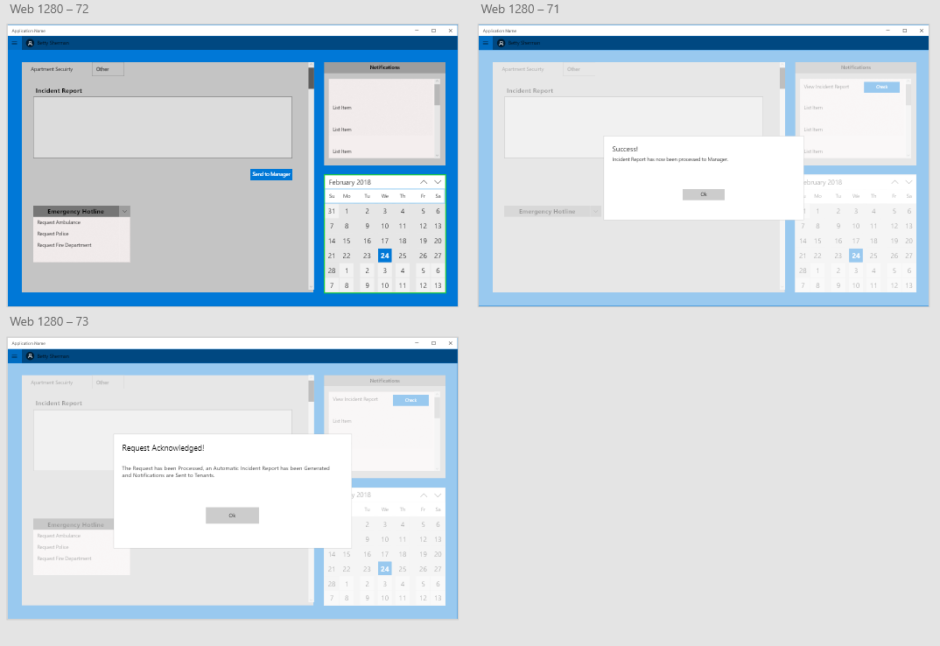

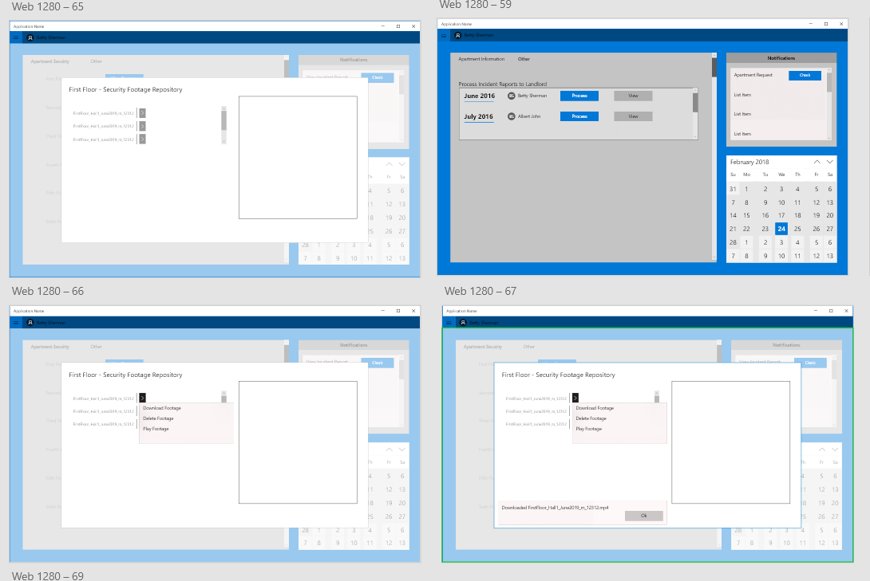
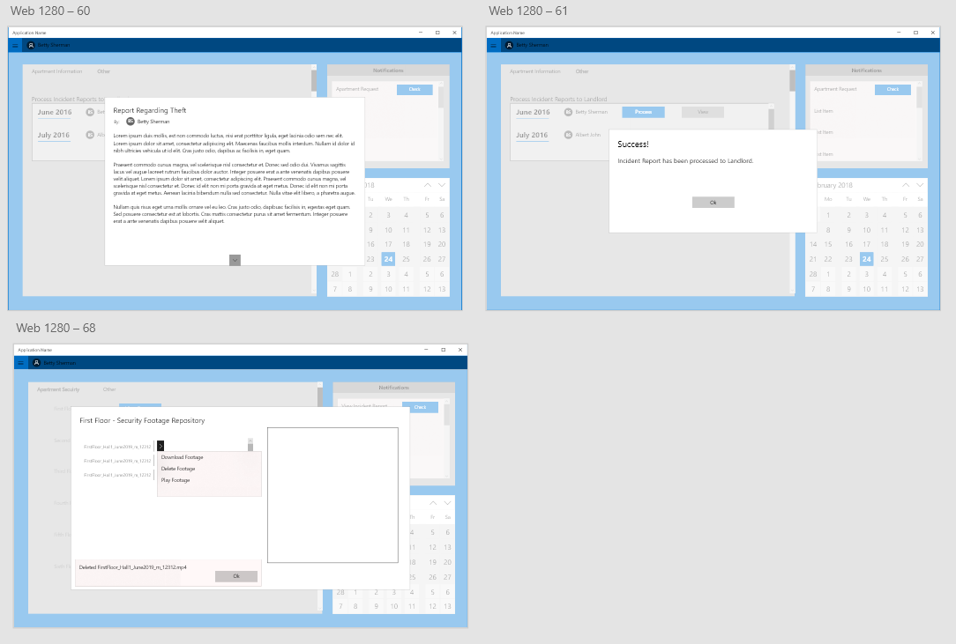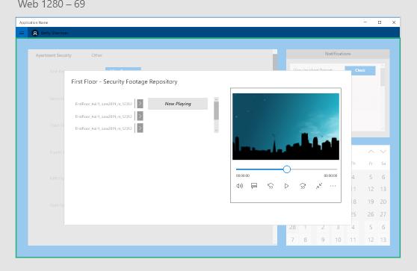

The Android App will be based on Material Google Design for Android 6.0.0 and Above.
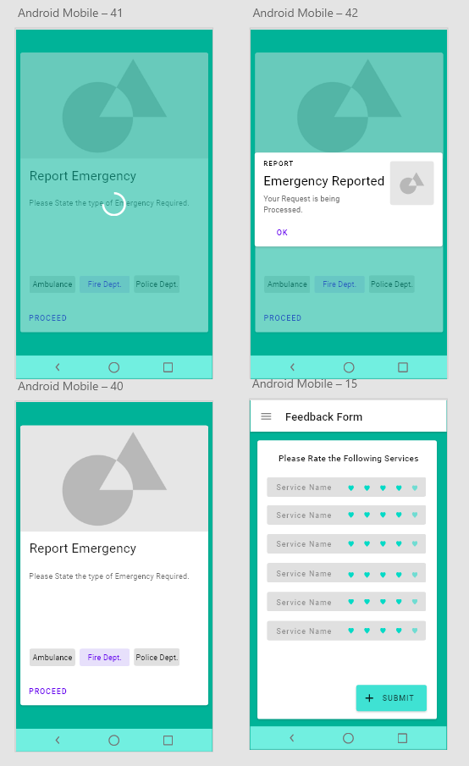
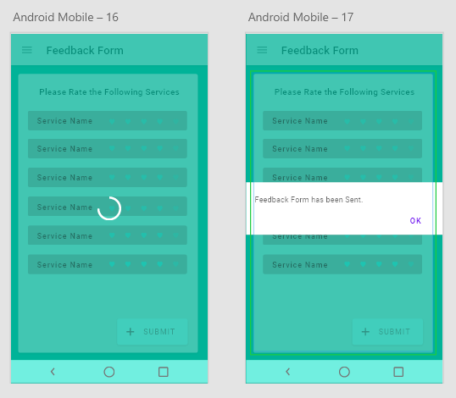
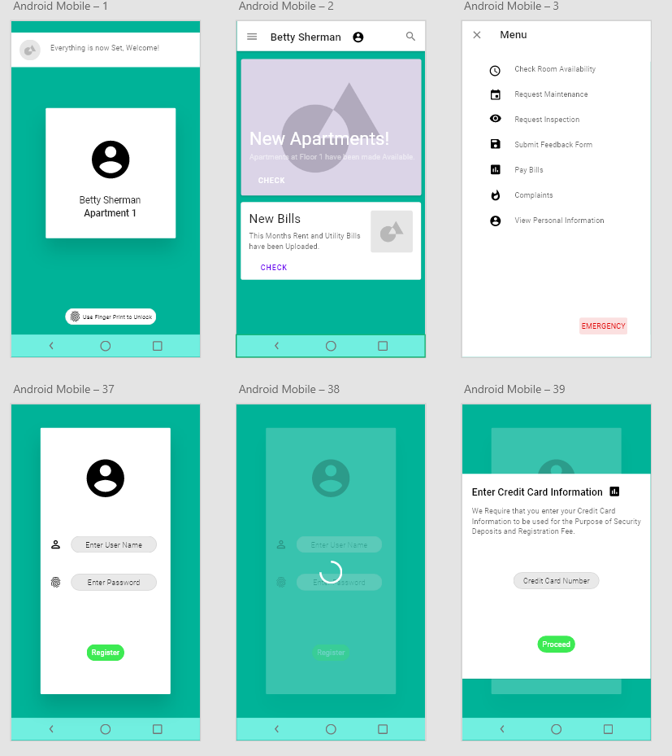
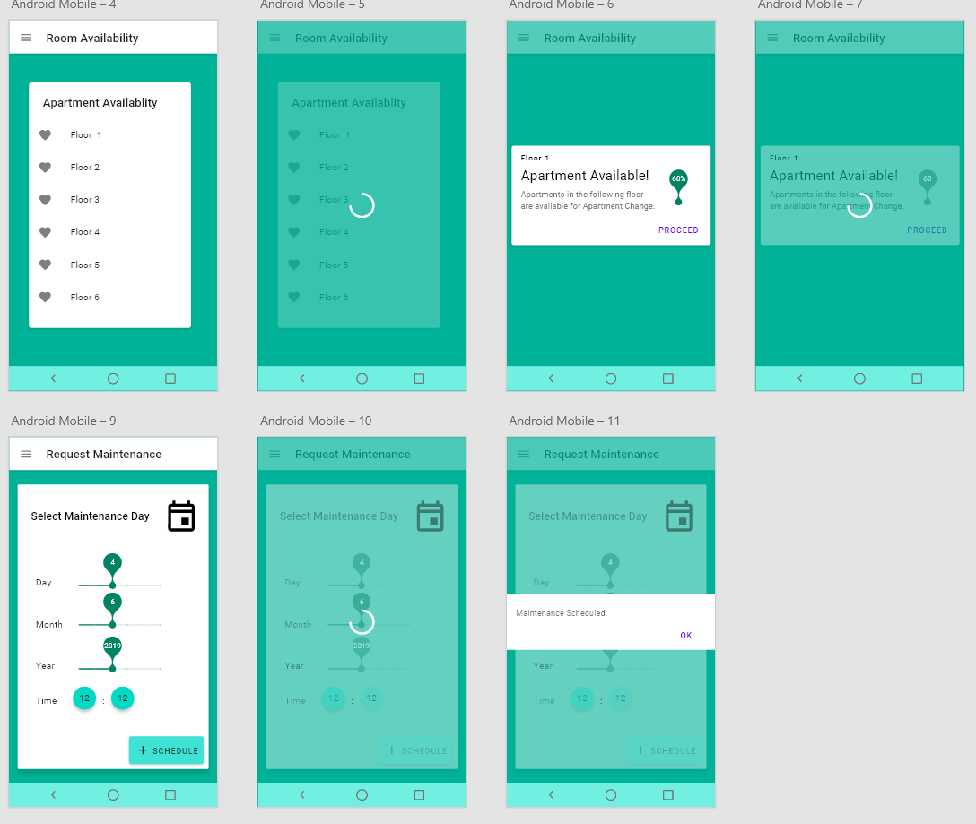
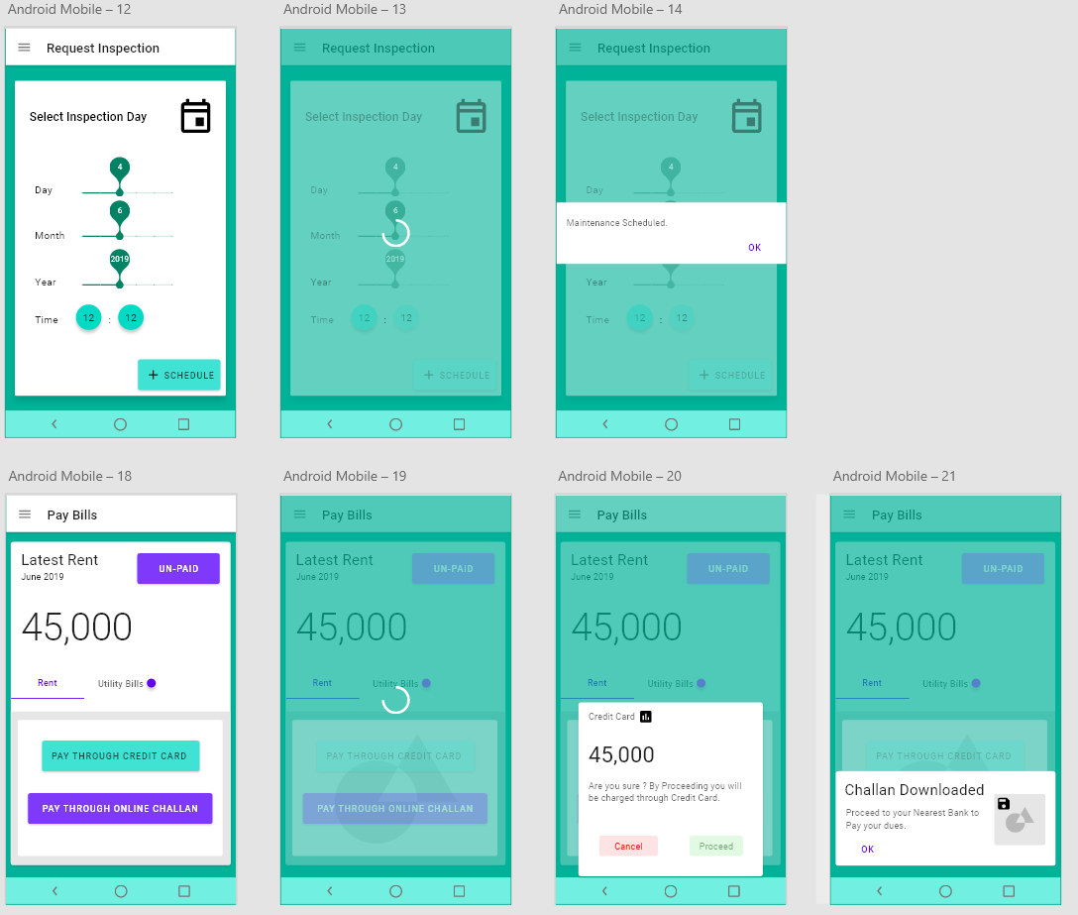
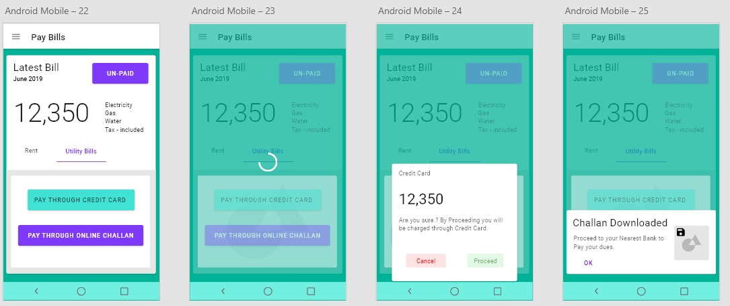

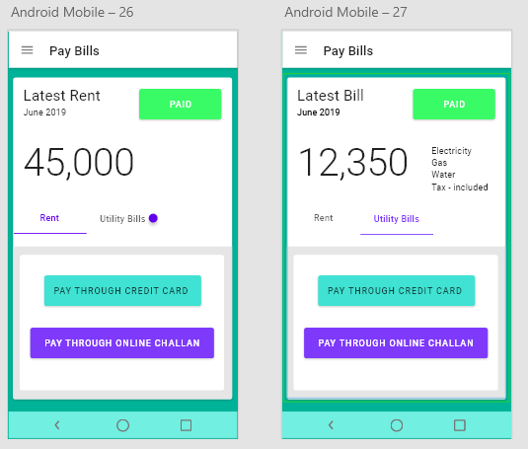
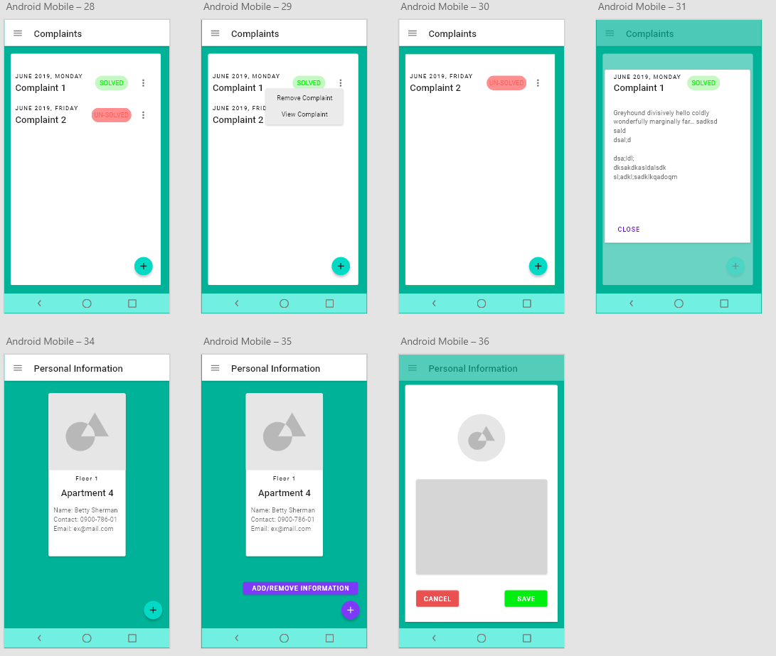
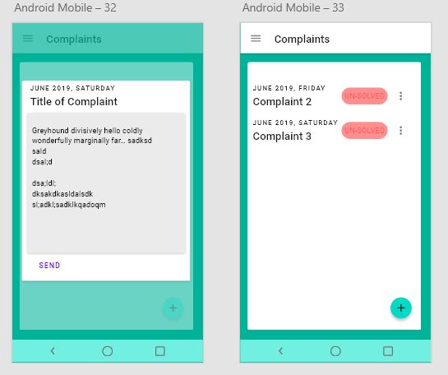

System Features

Use Case Model
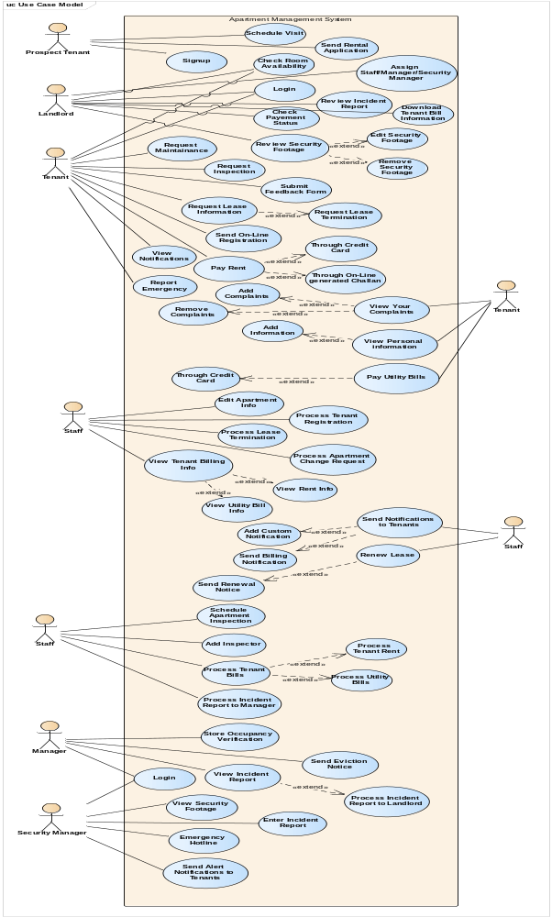

Use case Narratives

1. | Use Case Name: Schedule Visit
2. | Implementation Priority: 45
3. | Actors: Prospect Tenant
4. | Summary: Booking landlord time for visiting the apartments
5. | Pre-condition: The user should be logged into his/her account
6. | Post-condition: Time will be reserved for Prospect Tenant.
7. | Extend: -
8. | Include: Login
9. | Normal Course of Events:
 | System Actor Action | System Response
 | 1. Prospect Tenant will click on Schedule Visit.  3. User will enter all details/Information respectively. |  | 2. System will prompt the Screen having Form in which user will enter details (time, Date etc.) for Reservation of an Apartment Visit.  4. Then System Validates all information and proceeds.  5. Rservation will be made.
10. | Alternative Path: 4. If user does not fill the details properly then system shows the form again and requests for refilling.
11. | Exception: Database server not available

1. | Use Case Name: Send Rental application
2. | Implementation Priority: 1
3. | Actors: Prospect Tenant
4. | Summary: Sending an Application to Request for an Apartment.
5. | Pre-condition: The New User Must Register on the App first.
6. | Post-condition: An Application for an Apartment Request will be sent to the System.
7. | Extend: -
8. | Include: Login
9. | Normal Course of Events:
 | System Actor Action | System Response
 | 1. Prospect Tenant will click Send Rental Application  3. User will enter all details/Information respectively.  5.User verify the Information and click submit. |  | 2. System will prompt the Screen having Form in which user will enter details (Credit card Number and CVV etc.) to pay rent, Security Deposit.  4. Then System Validates all information and field boxes in the form are filled & asks user if he wants to edit or Confirm.  6 Rent Application will be submitted.
10. | Alternative Path: 4. If user does not fill the details properly then system shows the form again and requests for refilling.
11. | Exception: Database server not available

1. | Use Case Name: Check Room availability
2. | Implementation Priority: 2
3. | Actors: Landlord, Tenant, Staff
4. | Summary: To check the apartment availability and basic information
5. | Pre-condition: The user should be logged into his/her account
6. | Post-condition: Users will be prompted of different available apartments and their Basic Information
7. | Extend: -
8. | Include: Login
9. | Normal Course of Events:
 | System Actor Action | System Response
 | 1. Landlord, Tenant, Staff will click Check Room Availability.  3. User will See their Respective Information and Close the Window. |  | 2. System will prompt the Screen having information of Rooms Available.
10. | Alternative Path:
11. | Exception: Database server not available

1. | Use Case Name: Login
2. | Implementation Priority: 46
3. | Actors: Landlord, Tenant
4. | Summary: Enter their respective usernames and password to access System.
5. | Pre-condition:
6. | Post-condition: User Logins to the System.
7. | Extend: -
8. | Include: Login
9. | Normal Course of Events:
 | System Actor Action | System Response
 | 1. user will select the option of their designation and enter the password. |  | 2.System will validate the password and open the page having services options.
10. | Alternative Path:
11. | Exception: Database server not available

1. | Use Case Name: Check payment status
2. | Implementation Priority: 3
3. | Actors: Landlord, Staff, Manager
4. | Summary: To clearly know the payment status of an apartment.
5. | Pre-condition: The user should be logged into his/her account
6. | Post-condition: Landlord can check the payment status to know whether the tenant pays the rent, or the apartment payment is on time.
7. | Extend: -
8. | Include: Login
9. | Normal Course of Events:
 | System Actor Action | System Response
 | 1. Landlord, Staff or Manager will click Check Payment Status.  3. User will See their Respective Information and Close the Window. |  | 2. System will prompt the Screen having information of Payment Status.
10. | Alternative Path:
11. | Exception: Database server not available

1. | Use Case Name: Review security footage
2. | Implementation Priority: 44
3. | Actors: Security Manager
4. | Summary: To review the CCTV footages of the apartment.
5. | Pre-condition: Login
6. | Post-condition:
7. | Extend: Remove the Footage
8. | Include: Login
9. | Normal Course of Events:
 | System Actor Action | System Response
 | 1. Security Manager will select the Review Security Footage Option.  3. User will Select a Footage from the Log. |  | 2. System will show up log of all Recorded Footage.  4. System will display the Recorded Footage.
10. | Alternative Path:
11. | Exception: Database server not available

1. | Use Case Name: Remove Security Footage
2. | Implementation Priority: 43
3. | Actors: Security Manager
4. | Summary: To Remove Security Footage.
5. | Pre-condition:
6. | Post-condition: Removes the CCTV security footages of Apartment
7. | Extend: -
8. | Include: Login
9. | Normal Course of Events:
 | System Actor Action | System Response
 | 1. Security Manager will select Remove Security Footage from the Log. |  | 2. System will Remove Selected Footage.
10. | Alternative Path:
11. | Exception: Database server not available

1. | Use Case Name: Request Maintenance
2. | Implementation Priority: 42
3. | Actors: Tenant, Staff
4. | Summary: To request the apartment Management for Maintenance.
5. | Pre-condition: Login
6. | Post-condition: Request for maintenance will be delivered to Management.
7. | Extend: -
8. | Include: Login
9. | Normal Course of Events:
 | System Actor Action | System Response
 | 1. Tenant will click the request maintenance option.  3. Tenant will Schedule Maintenance Time.  5. Staff will Process Request if feasible. |  | 2.System will prompt Scheduling Options.  4. System will Prompt Staff of Request.  6. System will now Schedule Maintenance for Tenant.
10. | Alternative Path:
11. | Exception: Database server not available

1. | Use Case Name: Request Inspection
2. | Implementation Priority: 41
3. | Actors: Tenant, Staff, Manager
4. | Summary: To submit a request to Inspect the building.
5. | Pre-condition: The user should be logged into his/her account
6. | Post-condition: Inspection will be Scheduled in System.
7. | Extend: -
8. | Include: Login
9. | Normal Course of Events:
 | System Actor Action | System Response
 | 1. Tenant will click the request Inspection option.  3. Tenant will Schedule Inspection Time.  5. Staff will Process Request if feasible. |  | 2.System will prompt Scheduling Options.  4. System will Prompt Staff of Request.  6. System will now Schedule Inspection for Tenant.
10. | Alternative Path:
11. | Exception: Database server not available

1. | Use Case Name: Submit feedback form
2. | Implementation Priority: 40
3. | Actors: Tenant
4. | Summary: To submit the feedback regarding management performance.
5. | Pre-condition: Login
6. | Post-condition: Submits the feedback regarding management performance.
7. | Extend: -
8. | Include: Login
9. | Normal Course of Events:
 | System Actor Action | System Response
 | 1. User will select Submit Feedback form.  3. User will fill the form and submit |  | 2. System will prompt the screen having the Feedback form.
10. | Alternative Path:
11. | Exception: Database server not available

1. | Use Case Name: Request lease information
2. | Implementation Priority: 4
3. | Actors: Staff, Tenant
4. | Summary: To request the Information regarding Lease.
5. | Pre-condition:
6. | Post-condition: Shows the Respective lease information of an apartment.
7. | Extend: -
8. | Include: Login
9. | Normal Course of Events:
 | System Actor Action | System Response
 | 1. User will select the option of Request lease information. |  | 2. System will verify and download Lease Information.
10. | Alternative Path:
11. | Exception: Database server not available
=
1. | Use Case Name: Request lease termination
2. | Implementation Priority: 5
3. | Actors: Tenant, Staff
4. | Summary: To Terminate the Lease of the apartment.
5. | Pre-condition: Login
6. | Post-condition: Terminates the Lease of the apartment.
7. | Extend: -
8. | Include: Login
9. | Normal Course of Events:
 | System Actor Action | System Response
 | 1. Select the option of Request lease Termination. |  | 2. System will Verify Transaction.  3. System will Send a Request for Lease Termination.
10. | Alternative Path:
11. | Exception: Database server not available

1. | Use Case Name: Pay Rent
2. | Implementation Priority: 6
3. | Actors: Tenant
4. | Summary: To Pay Monthly Rent of the apartment through various Means.
5. | Pre-condition: Login
6. | Post-condition: Monthly Rent of apartment will be paid online.
7. | Extend: - Through credit card, Through Online Challan
8. | Include: Login
9. | Normal Course of Events:
 | System Actor Action | System Response
 | 1. Tenant will select option of pay Rent  3. User will Select the option. |  | 2. System will prompt User of Various Options to Pay Rent.  4. System will proceed with Selected Method.
10. | Alternative Path:
11. | Exception: Database server not available

1. | Use Case Name: Through credit card
2. | Implementation Priority: 7
3. | Actors: Tenant
4. | Summary: To Pay rent through Credit card.
5. | Pre-condition: Login, Pay Through Credit Card
6. | Post-condition: Monthly Rent of apartment will be paid through Credit Card.
7. | Extend: -
8. | Include: Login
9. | Normal Course of Events:
 | System Actor Action | System Response
 | 1. User will select the option of pay rent through credit card. |  | 2. System will Pay User’s Rent through his/her Credit Card.
10. | Alternative Path:
11. | Exception: Database server not available, 3rd Party Credit Card System malfunction

1. | Use Case Name: Through online generated Challan
2. | Implementation Priority: 8
3. | Actors: Tenant
4. | Summary: To Pay rent through Online Generated Challan
5. | Pre-condition: Login, Pay Rent Though Online Challan
6. | Post-condition: A Challan Copy will be Generated.
7. | Extend: -
8. | Include: Login
9. | Normal Course of Events:
 | System Actor Action | System Response
 | 1. User will select the option of pay rent through online generated Challan |  | 2. System will Generate a Challan.
10. | Alternative Path:
11. | Exception: Database server not available

1. | Use Case Name: View Notifications
2. | Implementation Priority: 9
3. | Actors: Tenant, Staff, Manager, Security Manager, Administrator
4. | Summary: To View Quick Information regarding anything relevant.
5. | Pre-condition: Login
6. | Post-condition: View Notifications.
7. | Extend: -
8. | Include: Login
9. | Normal Course of Events:
 | System Actor Action | System Response
 | 2. User will click ‘Check’ for a Specific Notification. |  | 1. System will prompt various Notifications.  3. System will re-direct User to designated window.
10. | Alternative Path:
11. | Exception: Database server not available

1. | Use Case Name: View your complaints
2. | Implementation Priority: 11
3. | Actors: Tenants
4. | Summary: To view your previously submitted complaints
5. | Pre-condition: Login
6. | Post-condition: View the previously submitted complaints
7. | Extend: -
8. | Include: Login
9. | Normal Course of Events:
 | System Actor Action | System Response
 | 1.User will Select View Complaints  3. User will Select a Complaint |  | 2. System will prompt User to Complaints page and show all his/her Complaints  4. System will display Complaint
10. | Alternative Path:
11. | Exception: Database server not available

1. | Use Case Name: Remove Complaints
2. | Implementation Priority: 12
3. | Actors: Tenants
4. | Summary: To remove your previously submitted complaints
5. | Pre-condition: Login
6. | Post-condition: Selected Complaint is Removed
7. | Extend: -
8. | Include: Login
9. | Normal Course of Events:
 | System Actor Action | System Response
 | 1.User will Select View Complaints  3. User will select ‘Show More’ for a selected Complaint  5. User will Select ‘Remove Complaint’ |  | 2. System will show the list of complaints  4. System will show options to Remove Complaint  6. System will Remove Complaint
10. | Alternative Path:
11. | Exception: Database server not available

1. | Use Case Name: Add Complaints
2. | Implementation Priority: 10
3. | Actors: Tenants
4. | Summary: To Add complaints
5. | Pre-condition: The user should be logged into his/her account
6. | Post-condition: Tenant’s Complaint will be logged
7. | Extend: -
8. | Include: Login
9. | Normal Course of Events:
 | System Actor Action | System Response
 | 1. Tenant will Click on Add Complain  3. User will enter the details and submit |  | 2. System will prompt the screen to enter complaint details  4. System will process the complaint & Display Confirmation message on screen.
10. | Alternative Path:
11. | Exception: Database server not available

1. | Use Case Name: View personal information
2. | Implementation Priority: 13
3. | Actors: Tenant
4. | Summary: To view the Personal Information
5. | Pre-condition:
6. | Post-condition: Shows Personal information of Tenant.
7. | Extend: Add Information
8. | Include: Login
9. | Normal Course of Events:
 | System Actor Action | System Response
 | 1. Tenant will select the option of view personal information |  | 2. System will show personal information of the Tenant.
10. | Alternative Path:
11. | Exception: Database server not available

1. | Use Case Name: Add Personal information
2. | Implementation Priority: 14
3. | Actors: Tenant
4. | Summary: To be able to Edit the Personal Information and add more Information.
5. | Pre-condition:
6. | Post-condition: Adds Personal information of Tenant.
7. | Extend: -
8. | Include: Login
9. | Normal Course of Events:
 | System Actor Action | System Response
 | 1. Tenant will select the option of Add personal information  3. User Enters the information and saves. |  | 2. System will prompt a Text Area, where the User can Enter as much relevant Information as needed.  5. System will save the information to Database
10. | Alternative Path:
11. | Exception: Database server not available

1. | Use Case Name: Pay Utility Bills
2. | Implementation Priority: 15
3. | Actors: Tenant
4. | Summary: Tenants can pay their Utility Bills online through various Payment Methods
5. | Pre-condition: Login
6. | Post-condition: Tenants will have paid their Utility Bills
7. | Extend: -Through Credit Card, Through Online Challan
8. | Include: Login
9. | Normal Course of Events:
 | System Actor Action | System Response
 | 1. Tenant will Select Pay Utility Bills  3. User will Select a Payment Option and proceed to pay his Utility Bills. |  | 2. System will prompt User to Billing Screen, where Billing Info is displayed, and Payment Options are shown.
10. | Alternative Path:
11. | Exception: Database server not available

1. | Use Case Name: Process Tenant registration
2. | Implementation Priority: 16
3. | Actors: Staff
4. | Summary: To Process an Apartment Registration Request by a Tenant or a Prospect Tenant
5. | Pre-condition: Login, Tenant Sends Apartment Registration Request
6. | Post-condition: Tenant Registration is processed
7. | Extend: -
8. | Include: Login
9. | Normal Course of Events:
 | System Actor Action | System Response
 | 1. Staff member will select the Process Tenant registration for an Apartment Registration Request |  | 2. System will add Tenant to Database and email Tenants to give relevant documents needed to complete Registration.
10. | Alternative Path:
11. | Exception: Database server not available

1. | Use Case Name: Process Lease Termination
2. | Implementation Priority: 17
3. | Actors: Staff
4. | Summary: To process the lease Termination of a Tenant
5. | Pre-condition:
6. | Post-condition: Process the lease Termination requests
7. | Extend: -
8. | Include: Login
9. | Normal Course of Events:
 | System Actor Action | System Response
 | 1. Staff member will select Lease Termination for a Selected Tenant |  | 2. System will Send Termination Notice to Tenants and Process Lease Cancellation
10. | Alternative Path:
11. | Exception: Database server not available

1. | Use Case Name: Process Apartment Change Request
2. | Implementation Priority:
3. | Actors: Staff
4. | Summary: To process the Request of an Apartment Change by a Tenant
5. | Pre-condition: Login
6. | Post-condition: Tenant Apartment Change is processed
7. | Extend: -
8. | Include: Login
9. | Normal Course of Events:
 | System Actor Action | System Response
 | 1. Staff Member will Select the process Apartment Change Request |  | 2. System will Email Tenants of Processing and Ask them to deliver Relevant Documents
10. | Alternative Path:
11. | Exception: Database server not available

1. | Use Case Name: Download Tenant billing information
2. | Implementation Priority: 18
3. | Actors: Staff
4. | Summary: To View Tenant Billing information, such as Rent and Utility Bill info
5. | Pre-condition:
6. | Post-condition: Rent and Utility Bill Information is downloaded
7. | Extend: View Rent information, View Utility Bill Information
8. | Include: Login
9. | Normal Course of Events:
 | System Actor Action | System Response
 | 1. For a Selected Tenant, User will select Tenant Billing information. |  | 2. System will download Rent and Utility Bill File
10. | Alternative Path:
11. | Exception: Database server not available

1. | Use Case Name: Download Rent Information
2. | Implementation Priority: 19
3. | Actors: Staff
4. | Summary: To View Rent Information
5. | Pre-condition:
6. | Post-condition: Rent Information Downloaded
7. | Extend: -
8. | Include: Login
9. | Normal Course of Events:
 | System Actor Action | System Response
 | 1. Staff member will select download Rent and Utility File |  | 2. System will download Rent and Utility Bill File
10. | Alternative Path:
11. | Exception: Database server not available

1. | Use Case Name: Download Utility Billing information
2. | Implementation Priority: 20
3. | Actors: Staff
4. | Summary: To Download Utility Bill Information
5. | Pre-condition:
6. | Post-condition: Downloaded Utility Billing information
7. | Extend: -
8. | Include: Login
9. | Normal Course of Events:
 | System Actor Action | System Response
 | 1. User Selects, download Rent and Utility File |  | 2. System will download Rent and Utility File
10. | Alternative Path:
11. | Exception: Database server not available

1. | Use Case Name: Send Notifications to Tenants
2. | Implementation Priority: 21
3. | Actors: Staff
4. | Summary: To Send Notifications to Tenants
5. | Pre-condition: Login
6. | Post-condition: Send Notifications to Tenants
7. | Extend: - Send Billing Notification, Add Custom Notification.
8. | Include: Login
9. | Normal Course of Events:
 | System Actor Action | System Response
 | 1. Staff Member Will select the Send Notification to Tenants |  | 2. System will Send Pre-Typed Messages to Tenants on different occasions
10. | Alternative Path:
11. | Exception: Database server not available

1. | Use Case Name: Add Custom Notification
2. | Implementation Priority: 22
3. | Actors: Staff, Managers, Security Managers, Landlord
4. | Summary: To add the Custom notification to notify Users
5. | Pre-condition: Login
6. | Post-condition: Sends a Custom Notification to the Tenants
7. | Extend: -
8. | Include: Login
9. | Normal Course of Events:
 | System Actor Action | System Response
 | 1. User will click on the Add Custom Notification.  3. User will enter the message and submit. |  | 2. System will open a dialogue box having text field to enter the Notification message.  4. System will send notification to all the Tenants.
10. | Alternative Path:
11. | Exception: Database server not available

1. | Use Case Name: Send Billing Notification
2. | Implementation Priority: 23
3. | Actors: Staff
4. | Summary: To notify the tenants about Bills
5. | Pre-condition:
6. | Post-condition: Notifications will be Sent to the Tenants
7. | Extend: -
8. | Include: Login
9. | Normal Course of Events:
 | System Actor Action | System Response
 | 1. Staff member will select send Billing Notification. |  | 2. System will Notify the tenants about bills.
10. | Alternative Path:
11. | Exception: Database server not available

1. | Use Case Name: Renewal Lease
2. | Implementation Priority: 24
3. | Actors: Staff
4. | Summary: To renew the Lease of Tenants
5. | Pre-condition:
6. | Post-condition: Lease period of Tenants will Renewed
7. | Extend: -send renewal notice
8. | Include: Login
9. | Normal Course of Events:
 | System Actor Action | System Response
 | 1. Staff member will select Renew Lease for a Selected Tenant |  | 2. System will Renew Lease and send Renewal Notice to Tenants
10. | Alternative Path:
11. | Exception: Database server not available

1. | Use Case Name: Send renewal notice
2. | Implementation Priority: 25
3. | Actors: Staff
4. | Summary: To Notify Tenants about Lease Renewal Processing
5. | Pre-condition:
6. | Post-condition: Notice for Tenant will be generated for renewal of lease.
7. | Extend: -
8. | Include: Login
9. | Normal Course of Events:
 | System Actor Action | System Response
 | 1. Staff member will select Send renewal notice |  | 2. System will send Notice to Tenant
10. | Alternative Path:
11. | Exception: Database server not available

1. | Use Case Name: Schedule Apartment inspection
2. | Implementation Priority: 26
3. | Actors: Staff, Tenant
4. | Summary: To Schedule Inspection of apartment
5. | Pre-condition:
6. | Post-condition: Schedule Inspection of apartment
7. | Extend: -
8. | Include: Login
9. | Normal Course of Events:
 | System Actor Action | System Response
 | 1.User will Select Schedule Inspection |  | 2.System will schedule the Apartment Inspection
10. | Alternative Path:
11. | Exception: Database server not available

1. | Use Case Name: Add inspector
2. | Implementation Priority: 27
3. | Actors: Staff
4. | Summary: To Add Inspector for Inspection of Apartment
5. | Pre-condition:
6. | Post-condition: Adds Inspector in System that conducts Scheduled Inspection
7. | Extend: -
8. | Include: Login
9. | Normal Course of Events:
 | System Actor Action | System Response
 | 1.Staff member will select Add Inspector  3. Staff member will enter the name |  | 2. System will Prompt User to Add Inspector Details  4. System will add the inspector
10. | Alternative Path:
11. | Exception: Database server not available

1. | Use Case Name: Process Tenant Bills
2. | Implementation Priority: 28
3. | Actors: Staff
4. | Summary: To Process the Tenant bills
5. | Pre-condition:
6. | Post-condition: Process /Send the bills to tenants
7. | Extend: Process tenant rent, Rrocess Utility bills
8. | Include: Login
9. | Normal Course of Events:
 | System Actor Action | System Response
 | 1. Staff member will select Process tenant bills |  | 2. System will Notify Tenants of their new dues needed to be paid
10. | Alternative Path:
11. | Exception: Database server not available

1. | Use Case Name: Process Tenant Rent
2. | Implementation Priority: 29
3. | Actors: Staff
4. | Summary: To Process the Tenant Rent
5. | Pre-condition:
6. | Post-condition: Processes / Send the Rent to Tenants
7. | Extend:
8. | Include: Login
9. | Normal Course of Events:
 | System Actor Action | System Response
 | 1. Staff member will select Process tenant Rent bills |  | 2. System will Process Tenant Rent and Notify Tenants
10. | Alternative Path:
11. | Exception: Database server not available

1. | Use Case Name: Process Tenant Utility Bills
2. | Implementation Priority: 30
3. | Actors: Staff
4. | Summary: To Process the Tenant Utility Bills
5. | Pre-condition:
6. | Post-condition: Processes / Sends the Utility Bill to Tenants
7. | Extend:
8. | Include: Login
9. | Normal Course of Events:
 | System Actor Action | System Response
 | 1. Staff member will select Process Tenant Utility bills |  | 2. System will Process Tenant Utility bills.
10. | Alternative Path:
11. | Exception: Database server not available

1. | Use Case Name: Process Incident Report to Manager
2. | Implementation Priority: 31
3. | Actors: Security Manager
4. | Summary: To send the incident report to manager
5. | Pre-condition:
6. | Post-condition: Sends Incident Report to Manager.
7. | Extend: -
8. | Include: Login
9. | Normal Course of Events:
 | System Actor Action | System Response
 | 1.Security Manager will form a Incident Report and click Process to Manager |  | 2. System will process the Incident Report to the Manager
10. | Alternative Path:
11. | Exception: Database server not available

1. | Use Case Name: Store occupancy verification
2. | Implementation Priority: 32
3. | Actors: Manager
4. | Summary: To Verify Store Occupancy
5. | Pre-condition:
6. | Post-condition: Occupancy Verification for a Tenant will be Stored
7. | Extend: -
8. | Include: Login
9. | Normal Course of Events:
 | System Actor Action | System Response
 | 1. Manager will select Store Occupancy when a Tenant has occupied an Apartment |  | 2. System will Store Occupancy Verification for the Tenant
10. | Alternative Path:
11. | Exception: Database server not available

1. | Use Case Name: Send eviction notice
2. | Implementation Priority: 33
3. | Actors: Manager
4. | Summary: To send an Eviction Notice will be Sent to Tenants
5. | Pre-condition:
6. | Post-condition: An Eviction Notice will be sent to Tenants
7. | Extend: -
8. | Include: Login
9. | Normal Course of Events:
 | System Actor Action | System Response
 | 1. User will select Send Eviction Notice to Tenant |  | 2. System will send an Eviction Notice to Tenant
10. | Alternative Path:
11. | Exception: Database server not available

1. | Use Case Name: View incident report
2. | Implementation Priority: 34
3. | Actors: Manager
4. | Summary: To view Incident report
5. | Pre-condition:
6. | Post-condition: Incident Report will be viewed by the Manager
7. | Extend: -
8. | Include: Login
9. | Normal Course of Events:
 | System Actor Action | System Response
 | 1. Manager will select View Incident Report |  | 2. System will show the incident report by the Security Manager
10. | Alternative Path:
11. | Exception: Database server not available

1. | Use Case Name: Process incident report to landlord
2. | Implementation Priority: 35
3. | Actors: Manager
4. | Summary: To Send Incident report to Land Lord
5. | Pre-condition:
6. | Post-condition: Sends Incident report to Landlord
7. | Extend: -
8. | Include: Login
9. | Normal Course of Events:
 | System Actor Action | System Response
 | 1. Manager will select Send Incident Report to Landlord.  3. Manager will select incident reports and submit |  | 2.System will give options to select the incident reports  4. System will send the report to Landlord.
10. | Alternative Path:
11. | Exception: Database server not available

1. | Use Case Name: View security footage
2. | Implementation Priority: 36
3. | Actors: Security Manager
4. | Summary: To view Security Footages of apartment
5. | Pre-condition:
6. | Post-condition: shows security CCTV footage of apartment.
7. | Extend: -
8. | Include: Login
9. | Normal Course of Events:
 | System Actor Action | System Response
 | 1. Security Manager will select View Security footage. |  | 2.System will show the CCTV footages of Apartment.
10. | Alternative Path:
11. | Exception: Database server not available

1. | Use Case Name: Enter Incident report
2. | Implementation Priority: 37
3. | Actors: Security Manager
4. | Summary: To Write Up an Incident Report
5. | Pre-condition: Login
6. | Post-condition: An Incident Report will be Recorded
7. | Extend: -
8. | Include: Login
9. | Normal Course of Events:
 | System Actor Action | System Response
 | 1. Security Manager will select Enter Incident Report  3. Security Manager will Enter the Incident report and Submit. |  | 2. System will prompt the screen to Enter the Incident report  4.System will save the Report.
10. | Alternative Path:
11. | Exception: Database server not available

1. | Use Case Name: Emergency Hotline
2. | Implementation Priority: 38
3. | Actors: Security Manager, Manager
4. | Summary: Security Manager can Request for Emergency.
5. | Pre-condition: Security Manager should be logged into his/her account
6. | Post-condition: Emergency Aid is Requested, and an Automatic Incident Report is generated.
7. | Extend: -
8. | Include: Login
9. | Normal Course of Events:
 | System Actor Action | System Response
 | 1. User Clicks Request for Emergency Aid.  3. User clicks required Service. |  | 2. A Pop-Up consisting of three Options (Police, Ambulance, Fire Department) is shown.  4. System Requests Selected Service.  5. Automatic Incident Report Generated and processed to Manager.
10. | Alternative Path:
11. | Exception: Database server not available, Emergency Hotline Busy

1. | Use Case Name: Send Alert Notifications to tenants
2. | Implementation Priority: 39
3. | Actors: Security Manager, Tenants
4. | Summary: To send Alert Notifications of Tenants
5. | Pre-condition: Emergency Hotline is initiated
6. | Post-condition: Users are notified of Emergency.
7. | Extend: -
8. | Include: Login
9. | Normal Course of Events:
 | System Actor Action | System Response
 | 1. User Requests for Emergency. |  | 2. System Accepts Request and generates an Incident Report to Send to the Manager.  3. System then Sends Notifications to Tenants, alerting them of the situation.
10. | Alternative Path:
11. | Exception: Database server not available, Hotline System unresponsive.

Activity Diagrams

Activity Diagram (Complete System)

Other Non-functional Requirements

Performance Requirements
- If a Server is faulty, functionality of Transmitting ongoing tasks to backup Servers to be implemented.
- Functionality to store periodic Backups of Database and Information, should a malfunction arise from Database Manager.

Safety Requirements
There is a possibility that abundant amount of valuable user data could potentially be stolen if there ever happens to be a Security Breach within the System. This could be prevented by adopting modern Security Protocols or using the assistance of a 3rd Party Security Solution to ensure Data is kept Safe.

Security Requirements
Possibilities of potential Security Breach could result in extreme damages to all the Users connected within the System. To ensure this does not happen, a Secure Login is to be created requiring a unique passcode for entrance. For Tenants the functionality of 2 factor Authentication is to be implemented which is currently the best Solution for a more Secure Login on Mobile Platforms.

Software Quality Attributes
The Software will be Designed in a way to ensure that there is steep learning curve to grasp the main fundamentals of the Products. The Product will be able to quickly adapt to various User Requests and will post pop-up Help Tips while exploring a new Functionality within the Product which has not been used yet. Various Design implementations will allow the Users to maintain usage of the Product for a long period of time and will also allow the Developers easily functionality within itself for easier Maintenance, which would be cost and time effective. With various Optimization Implementations and the choice of the Operating Systems used, the Product can be readily used on a much wider variety of Devices with less demanding requirements.

